Screenshots:

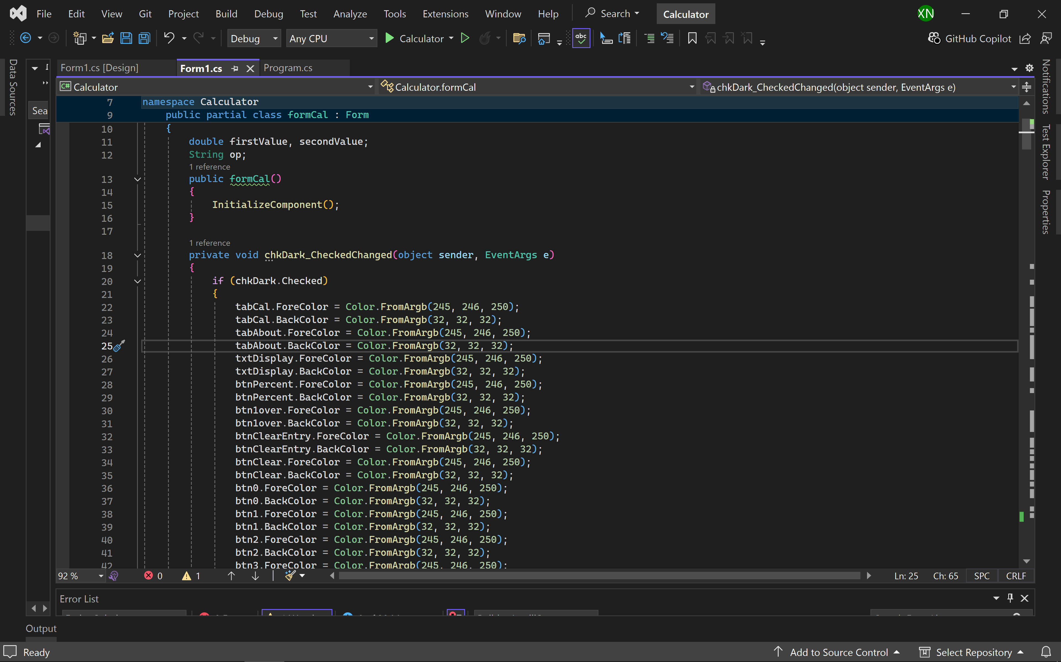

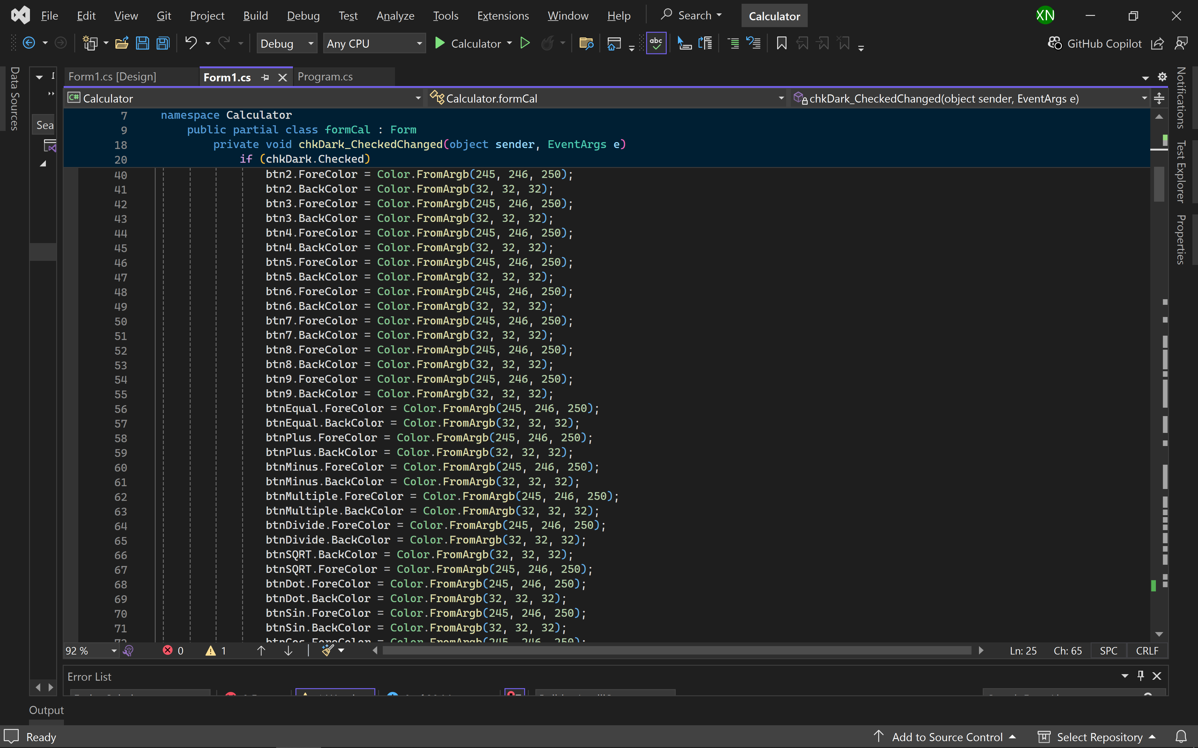

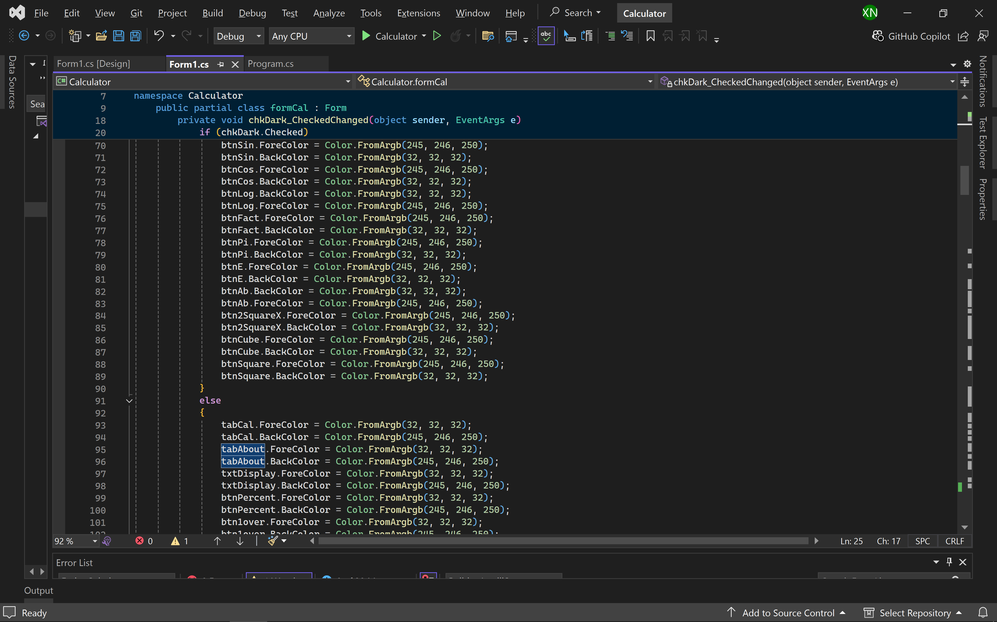

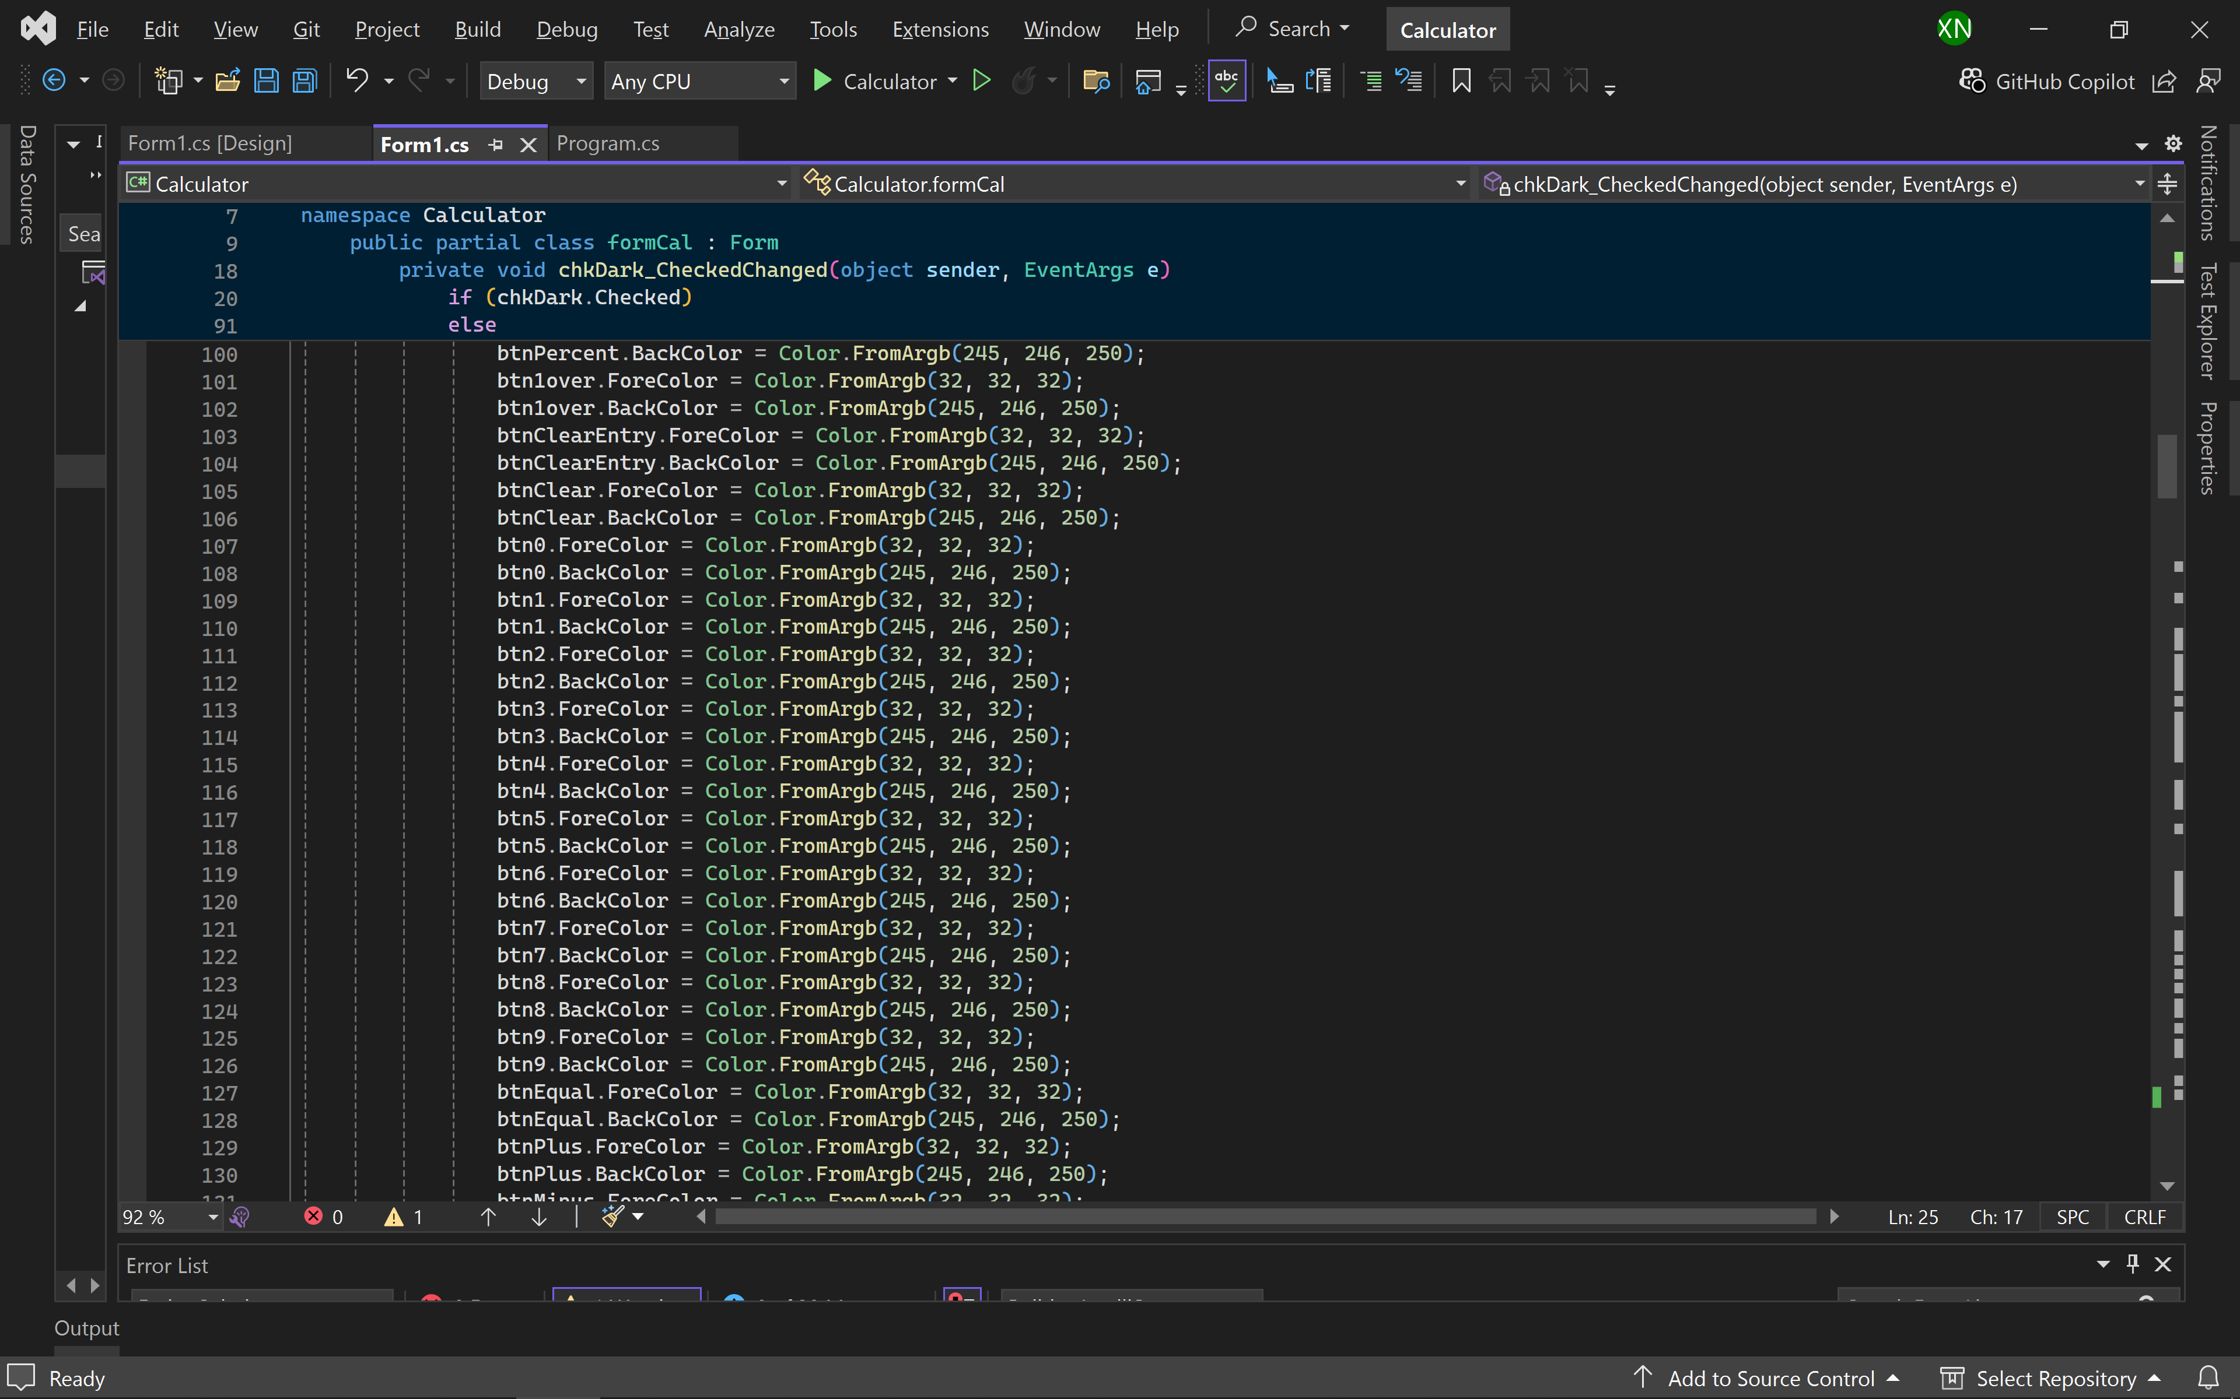

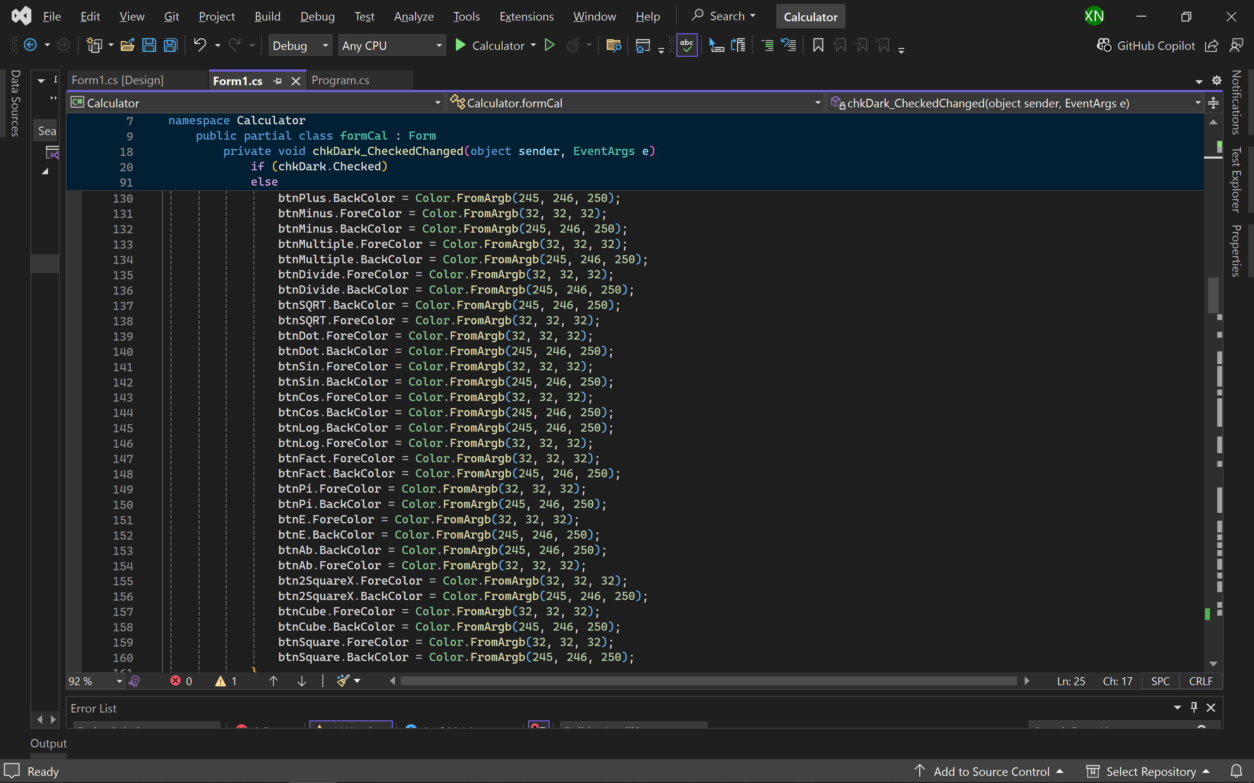

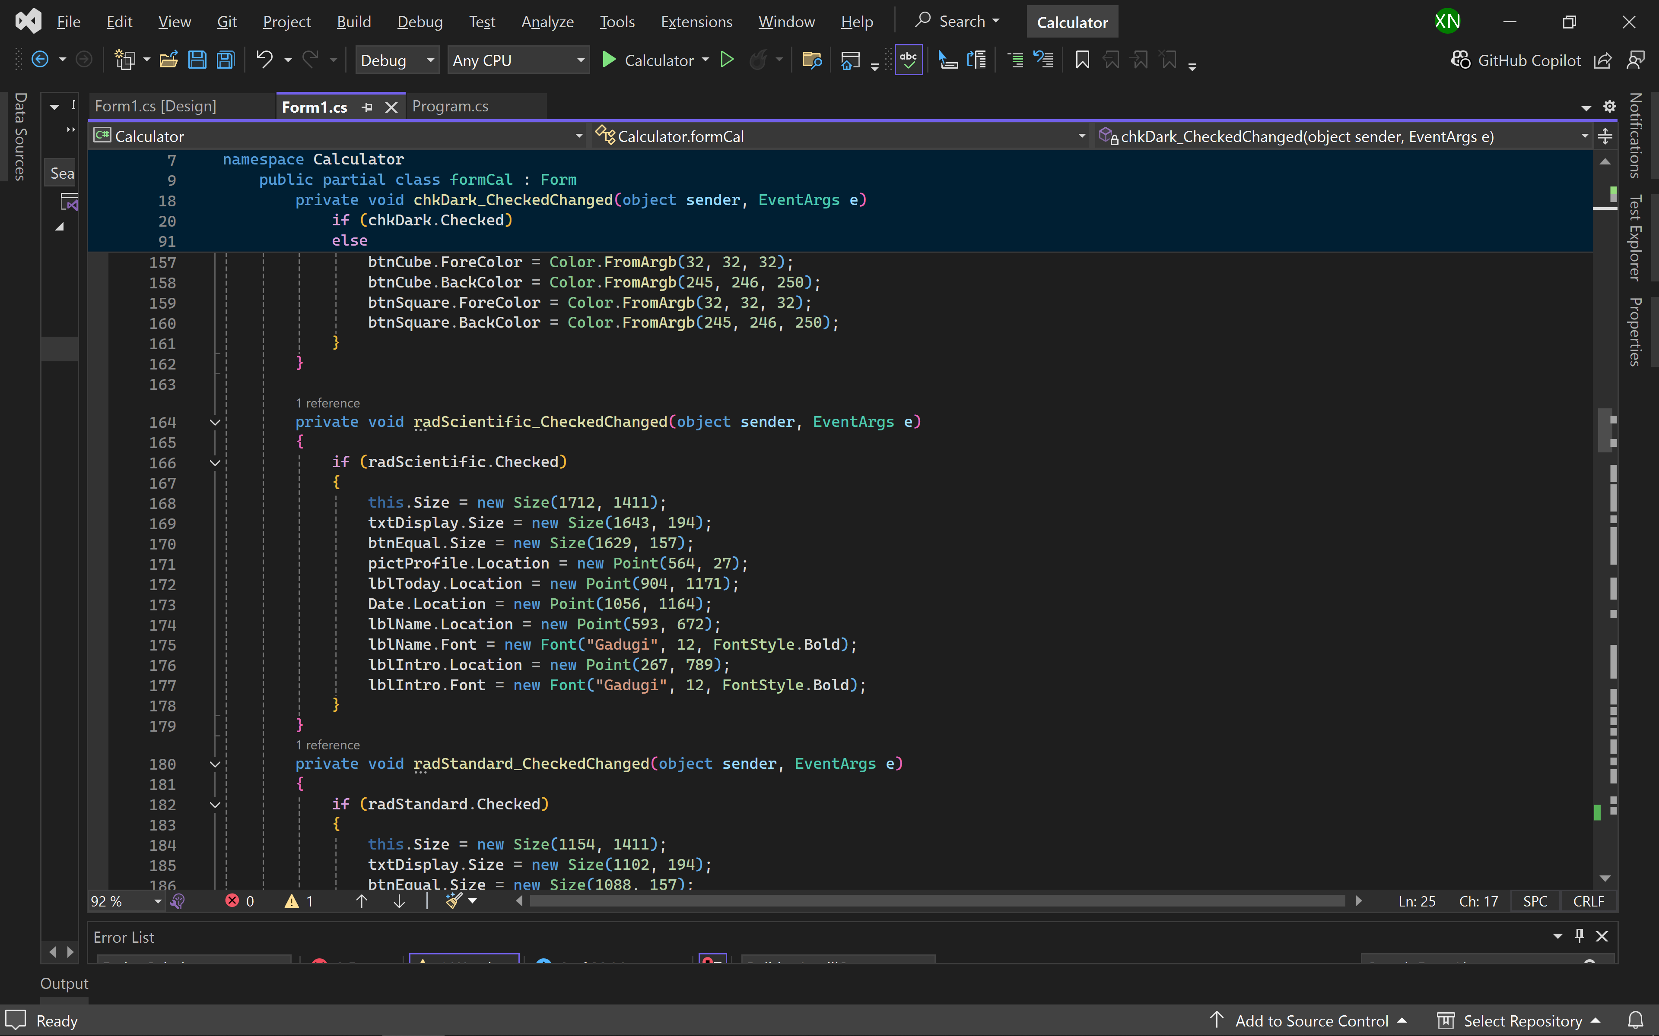

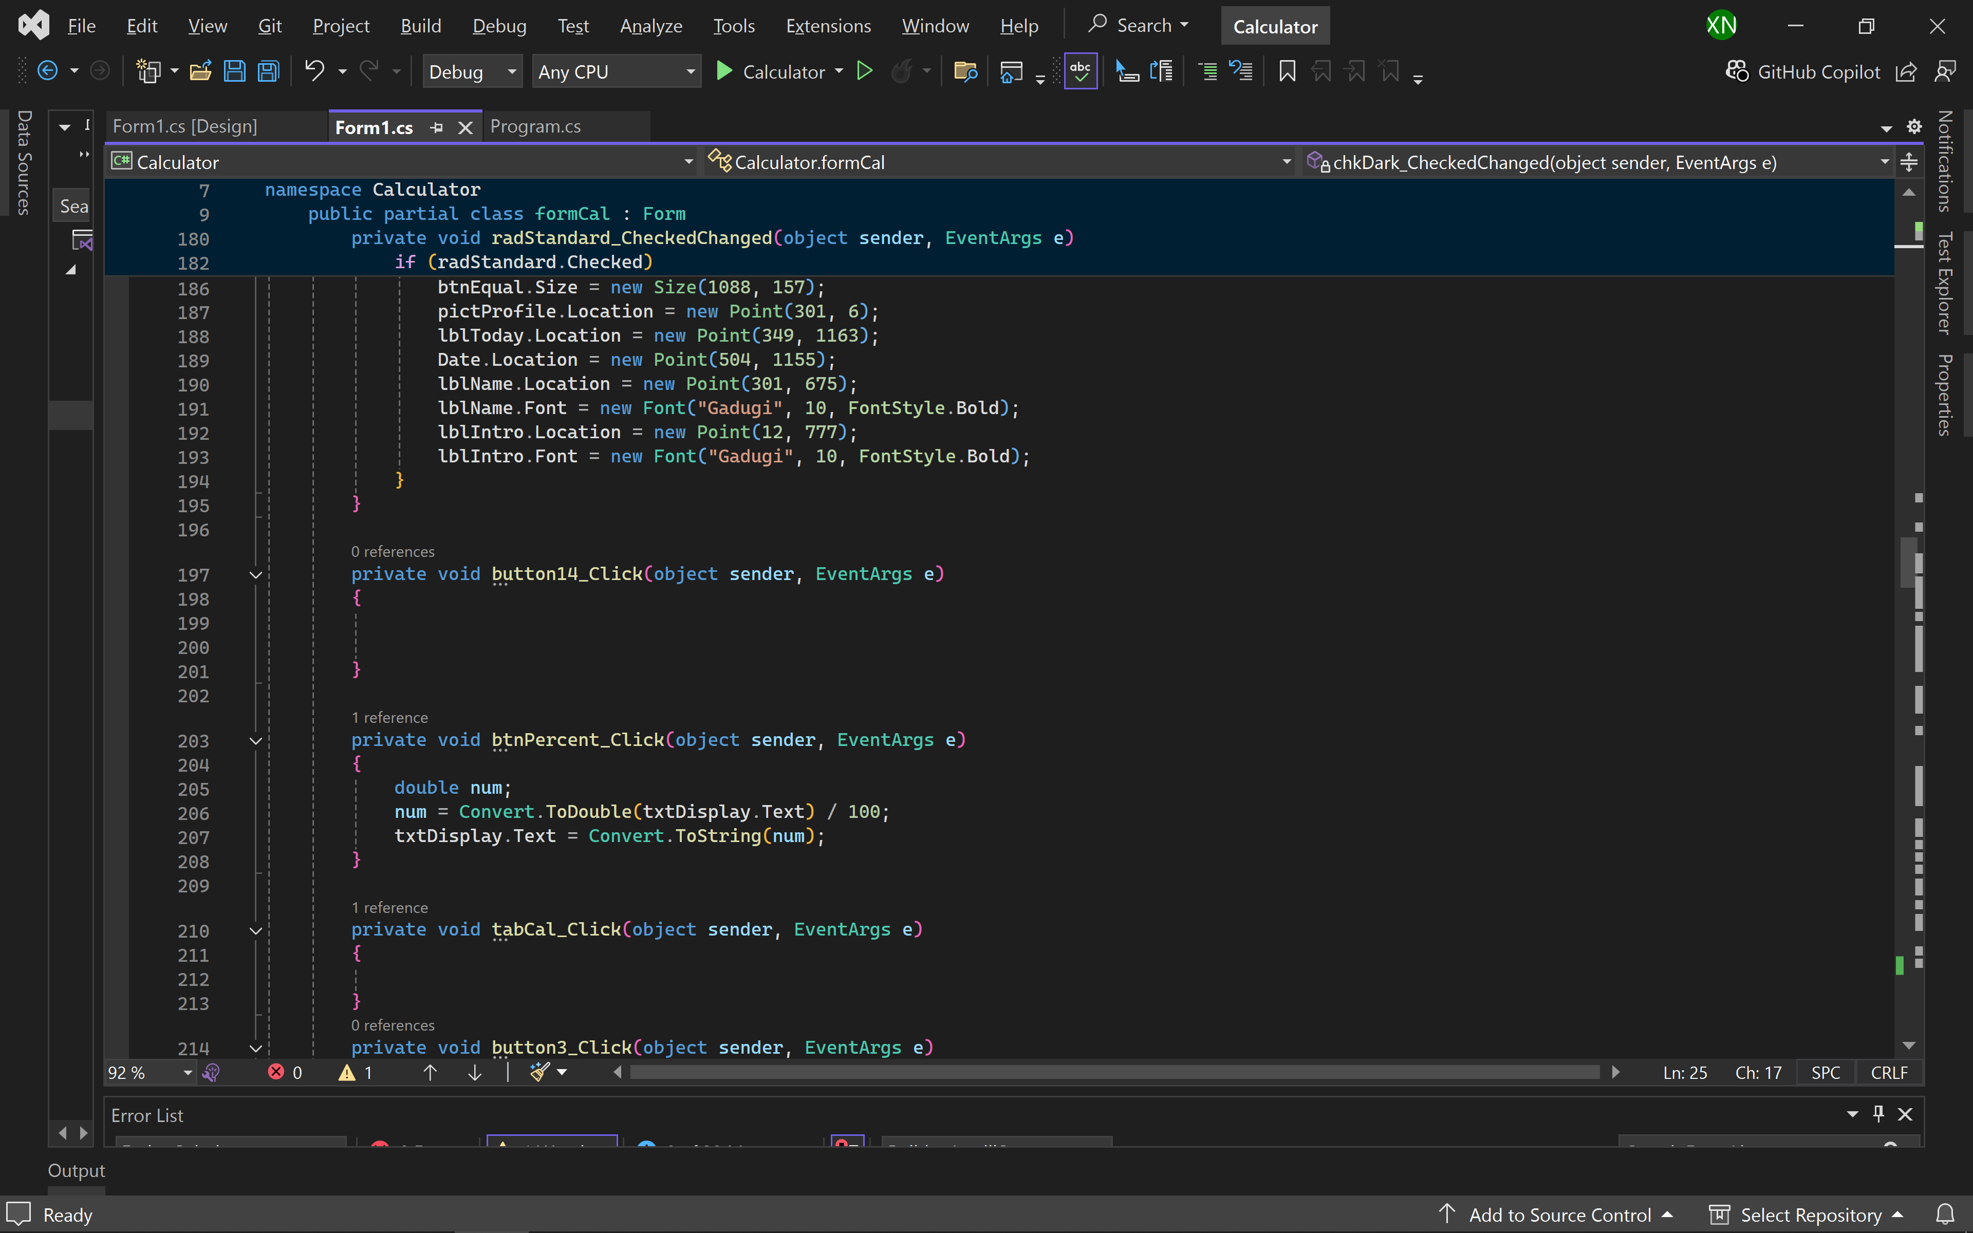

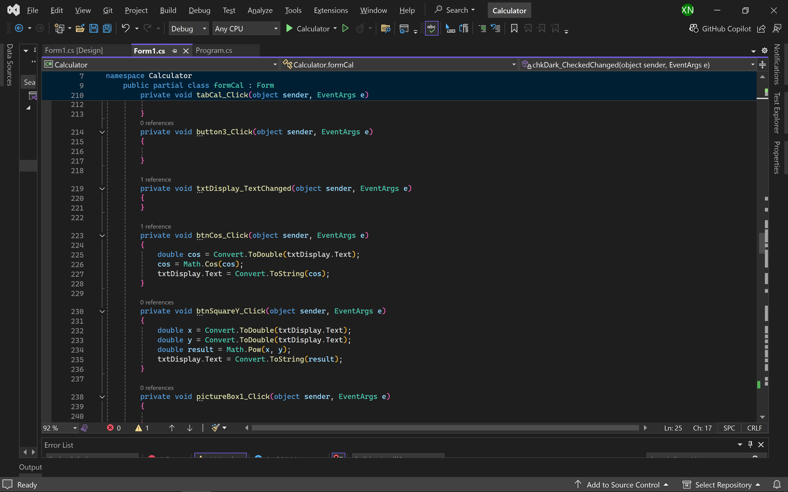

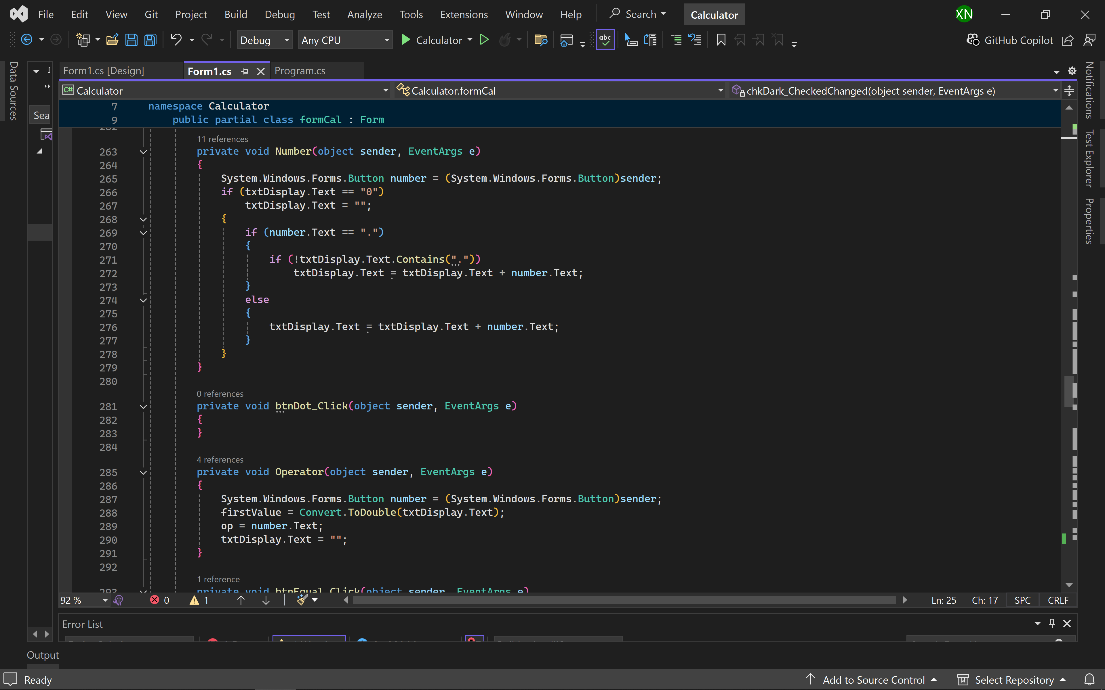

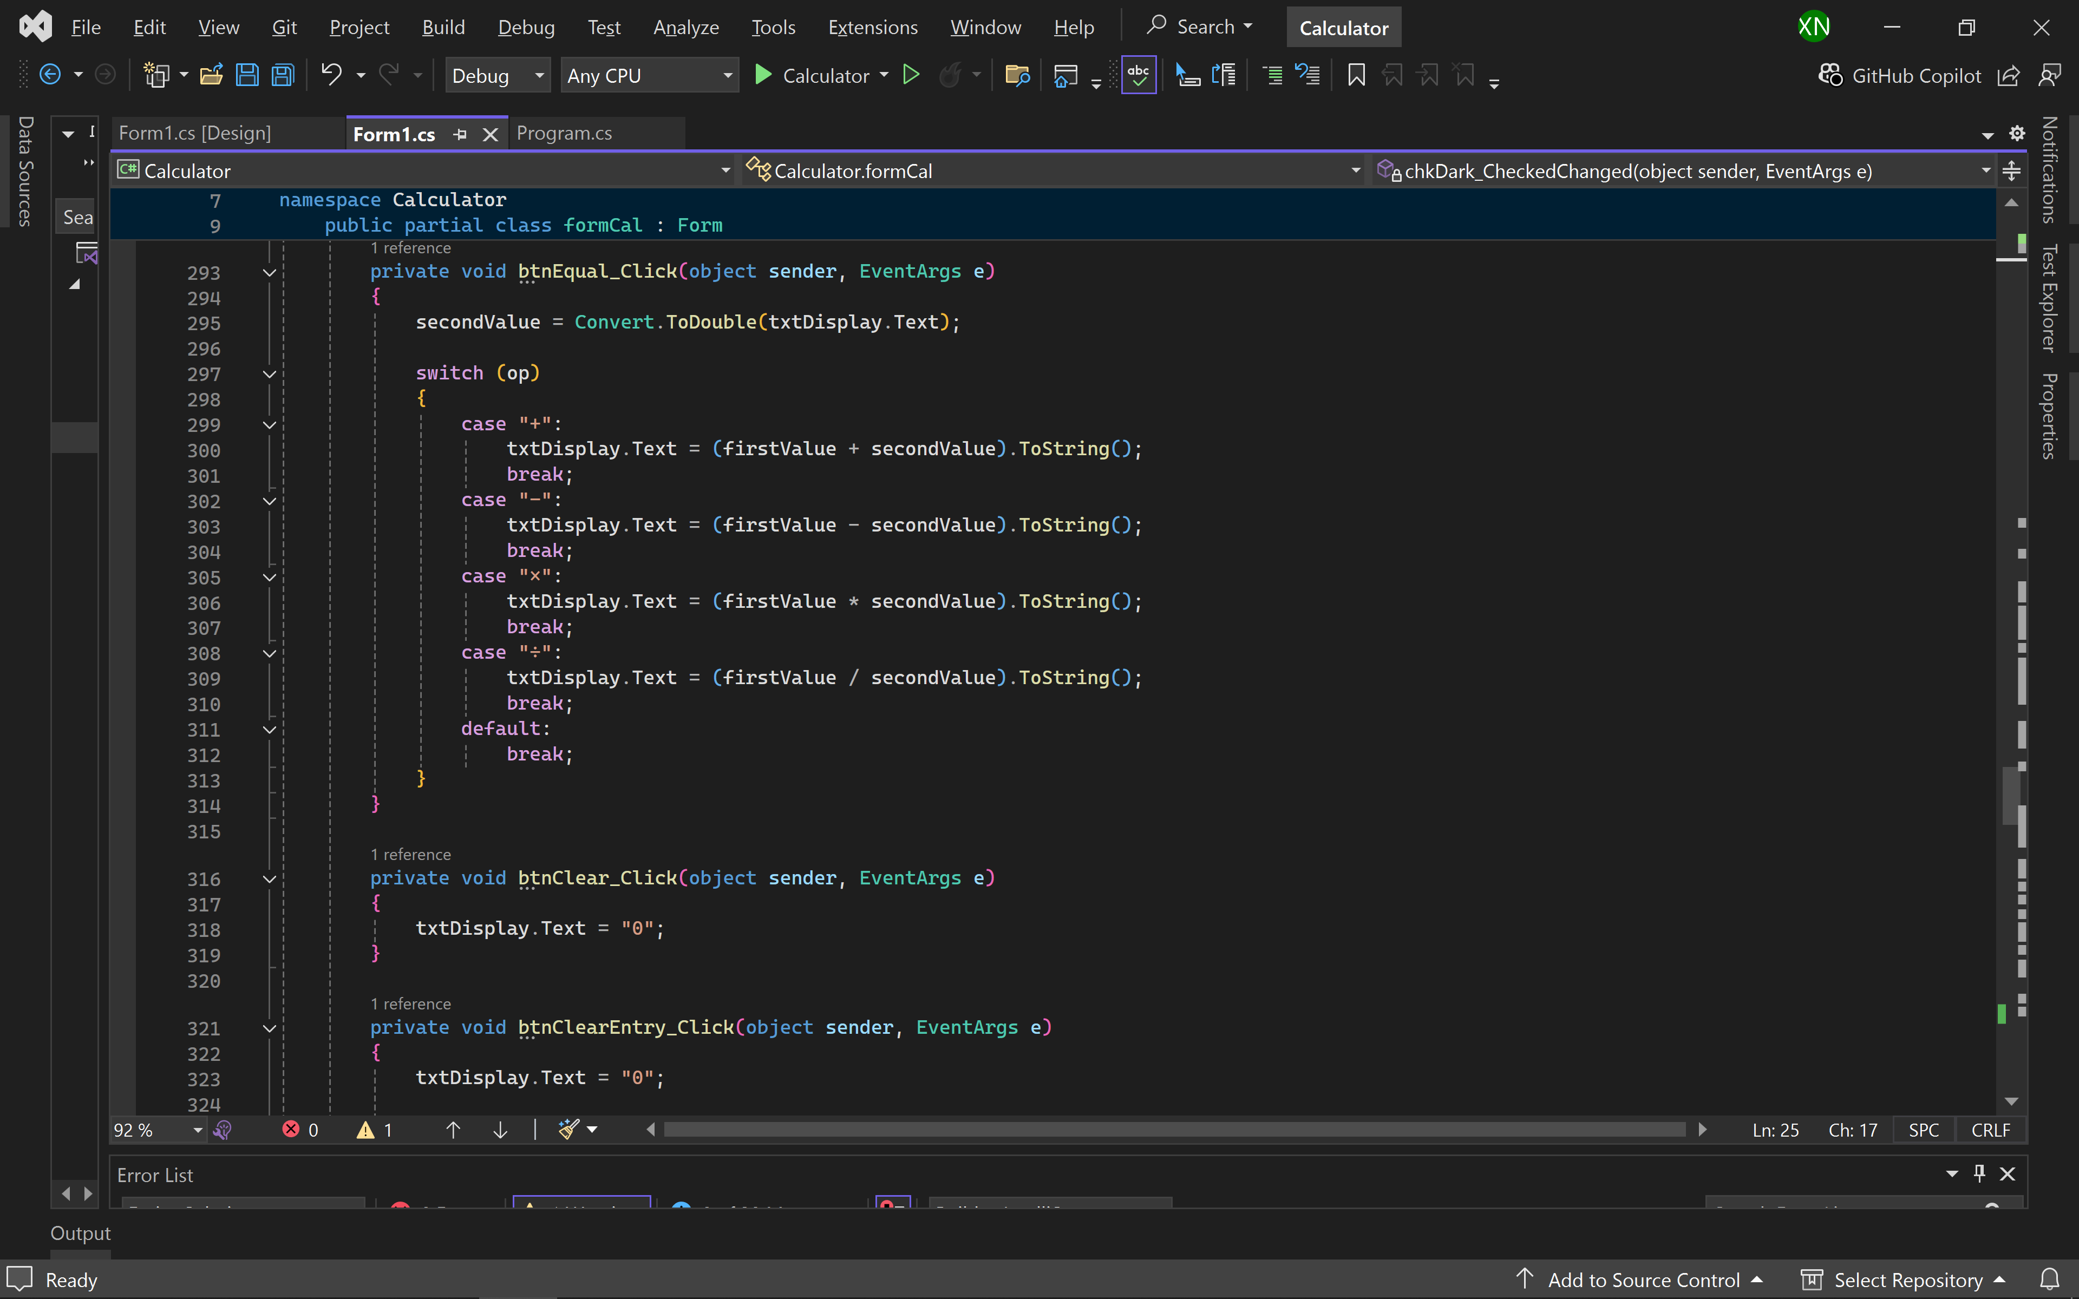

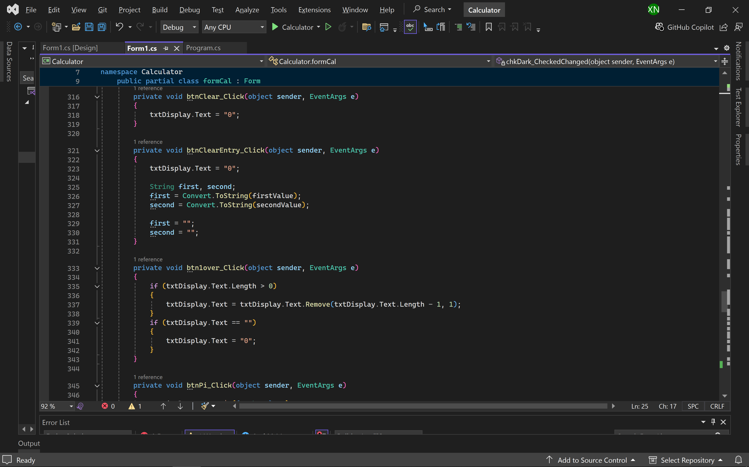

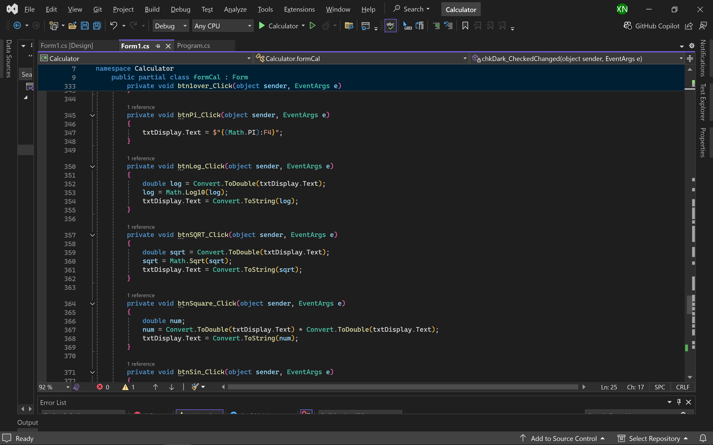

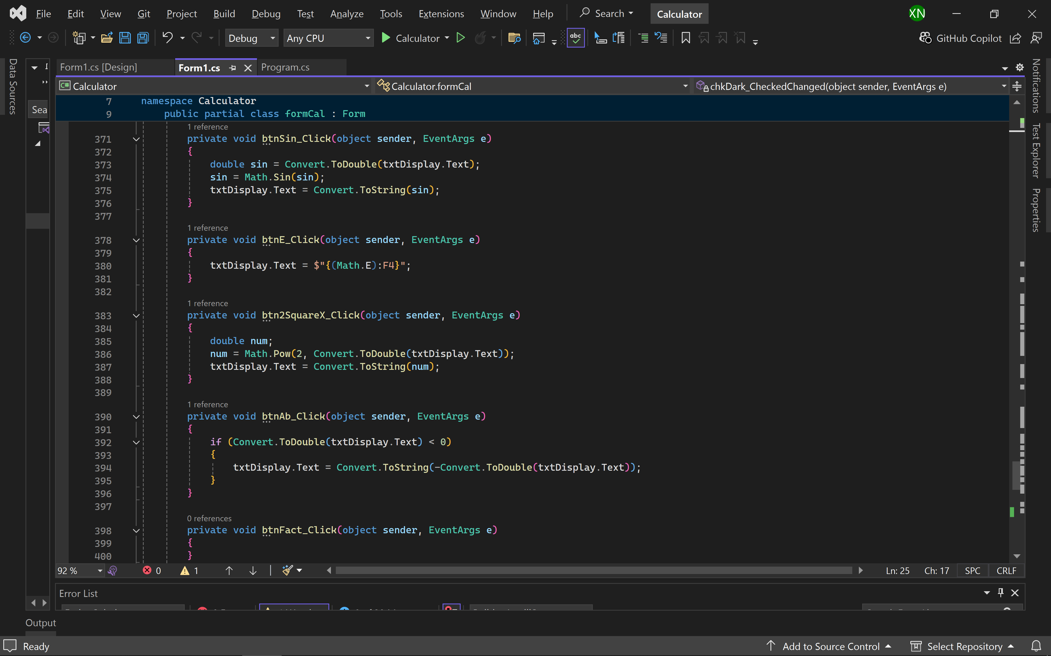

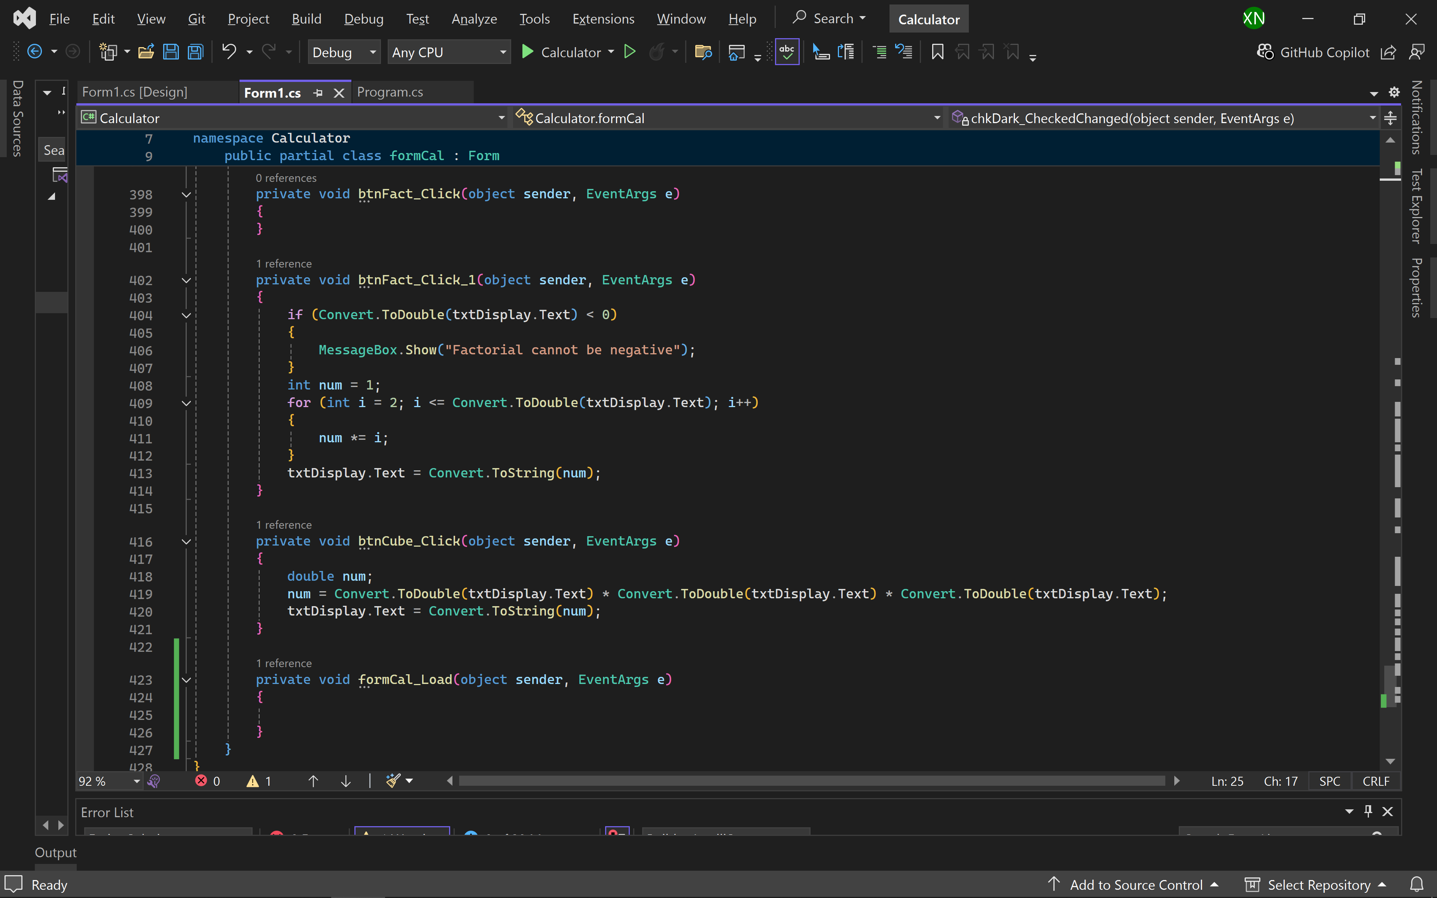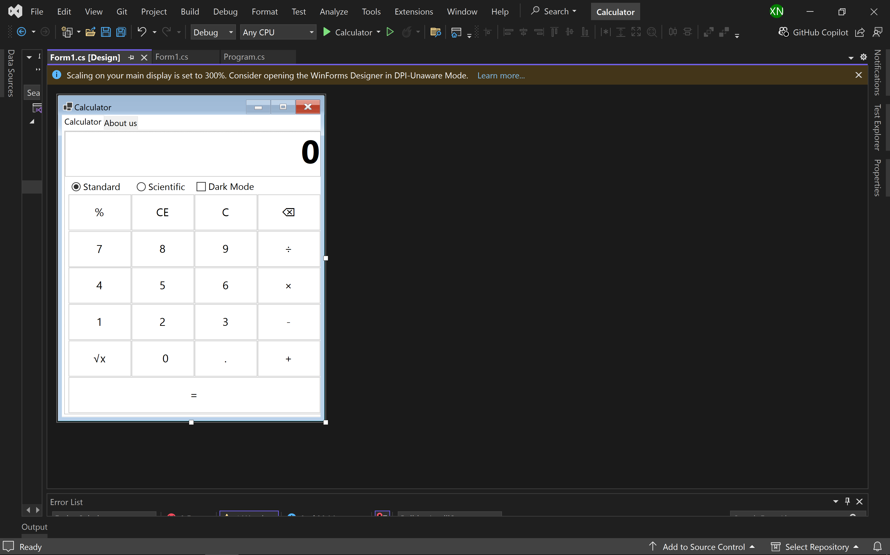

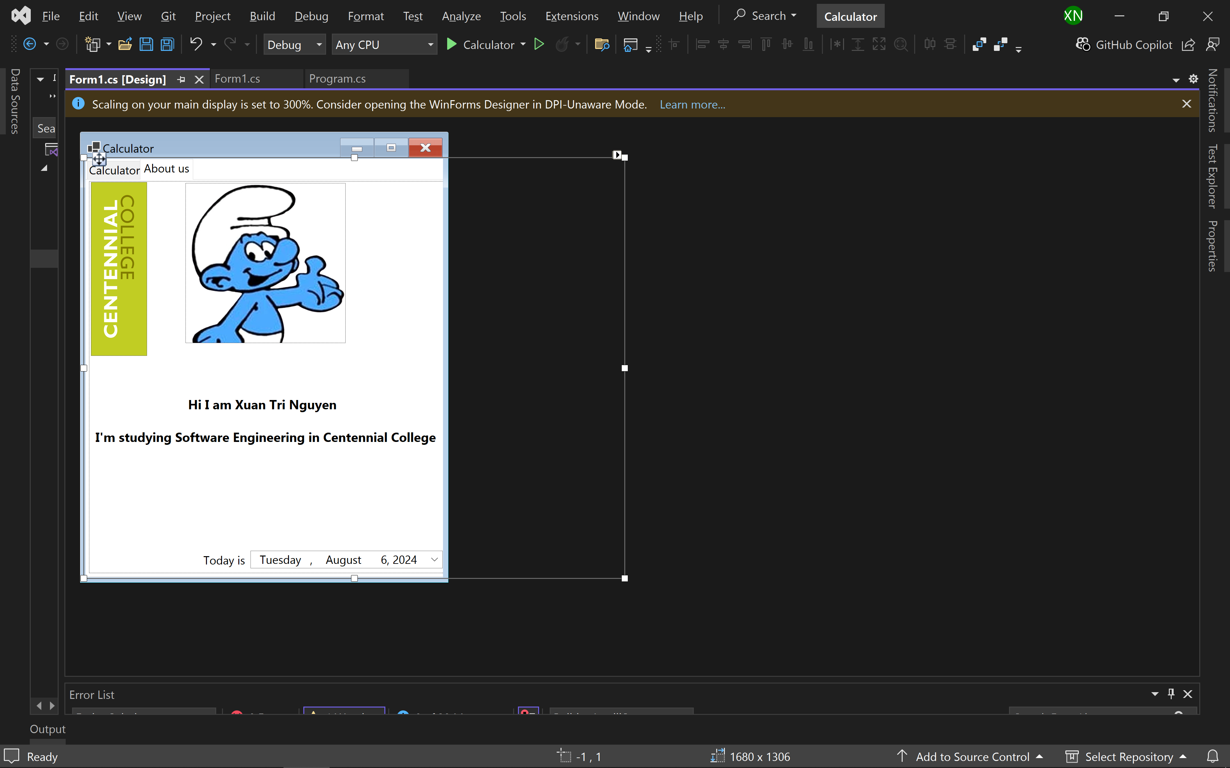

Output:

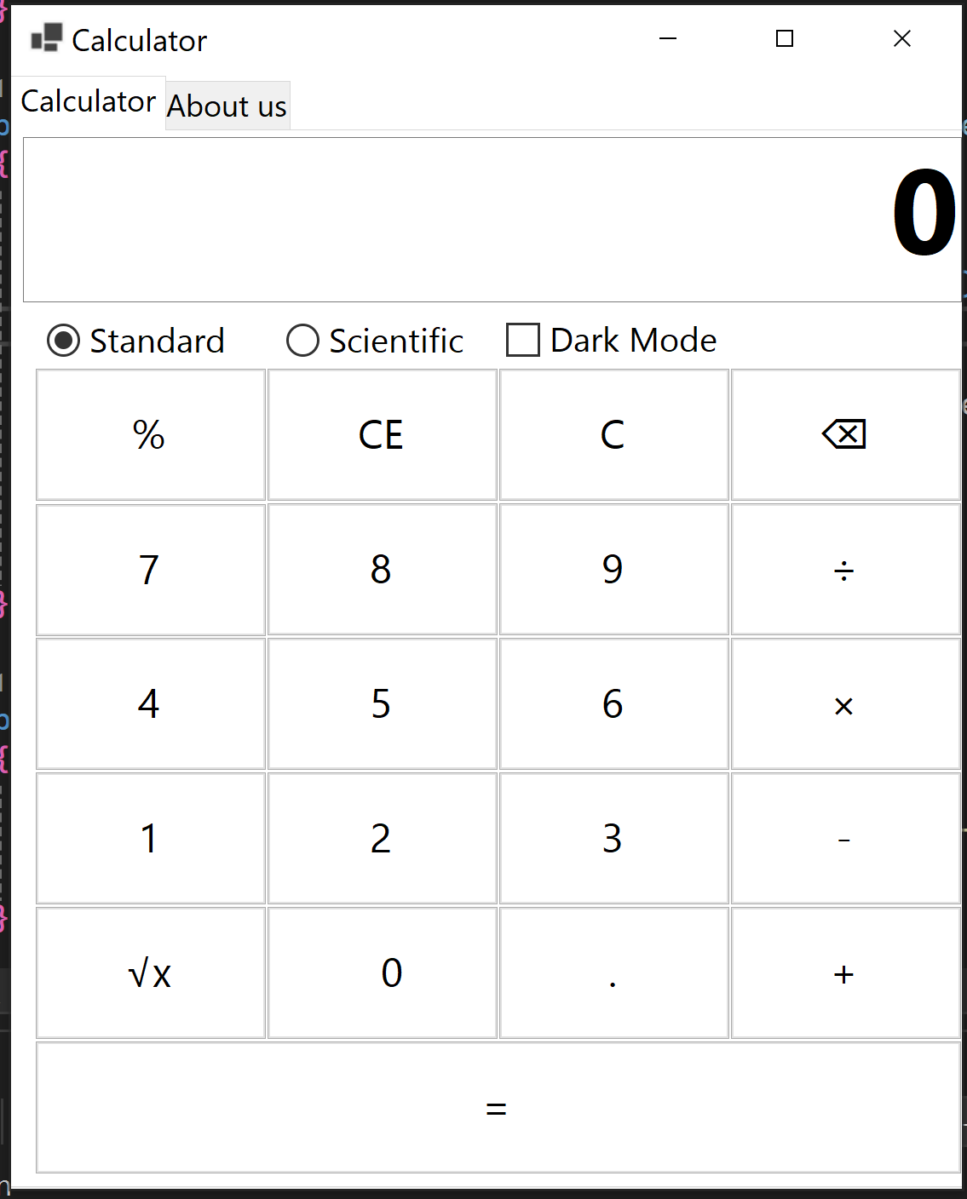

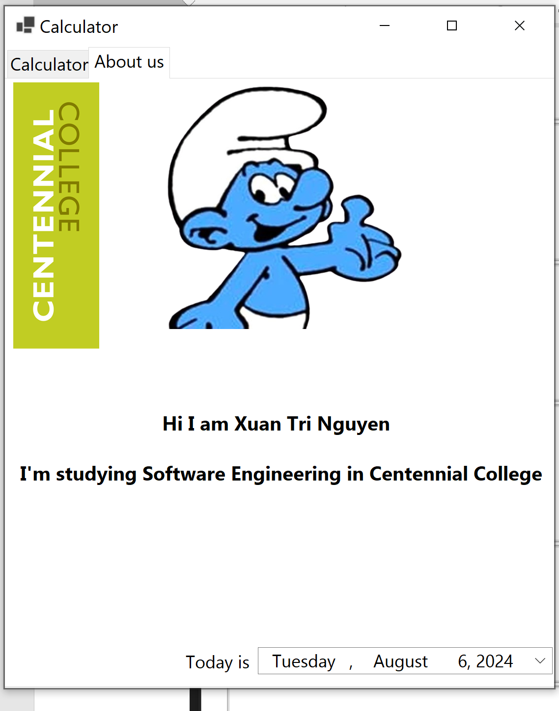

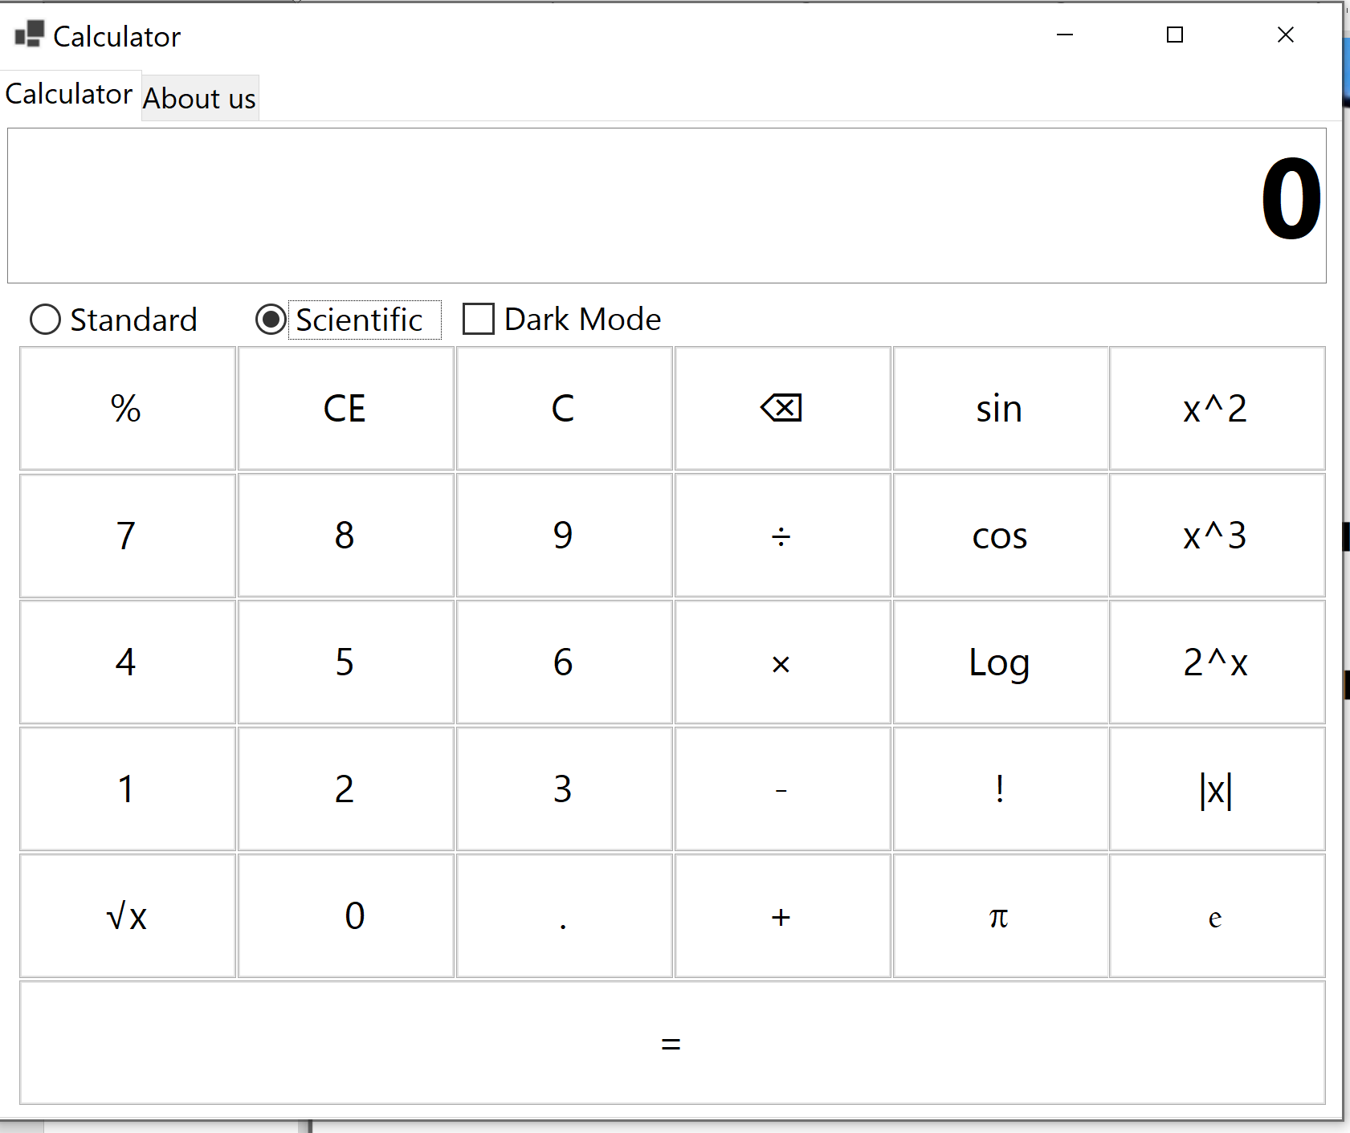

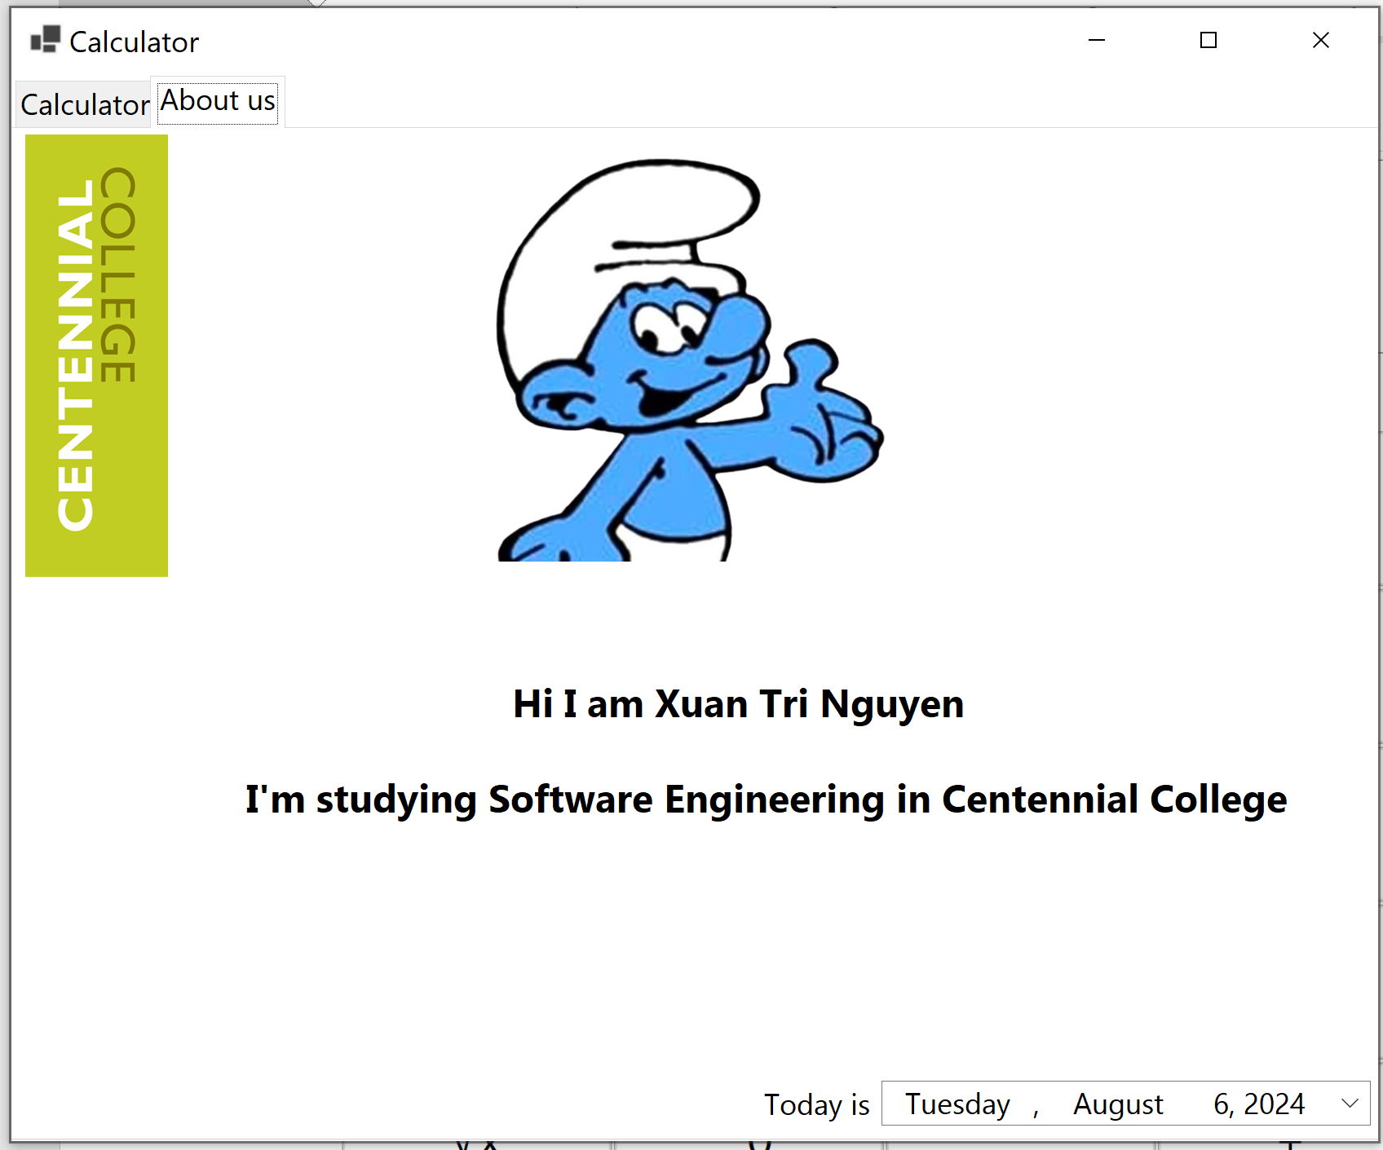

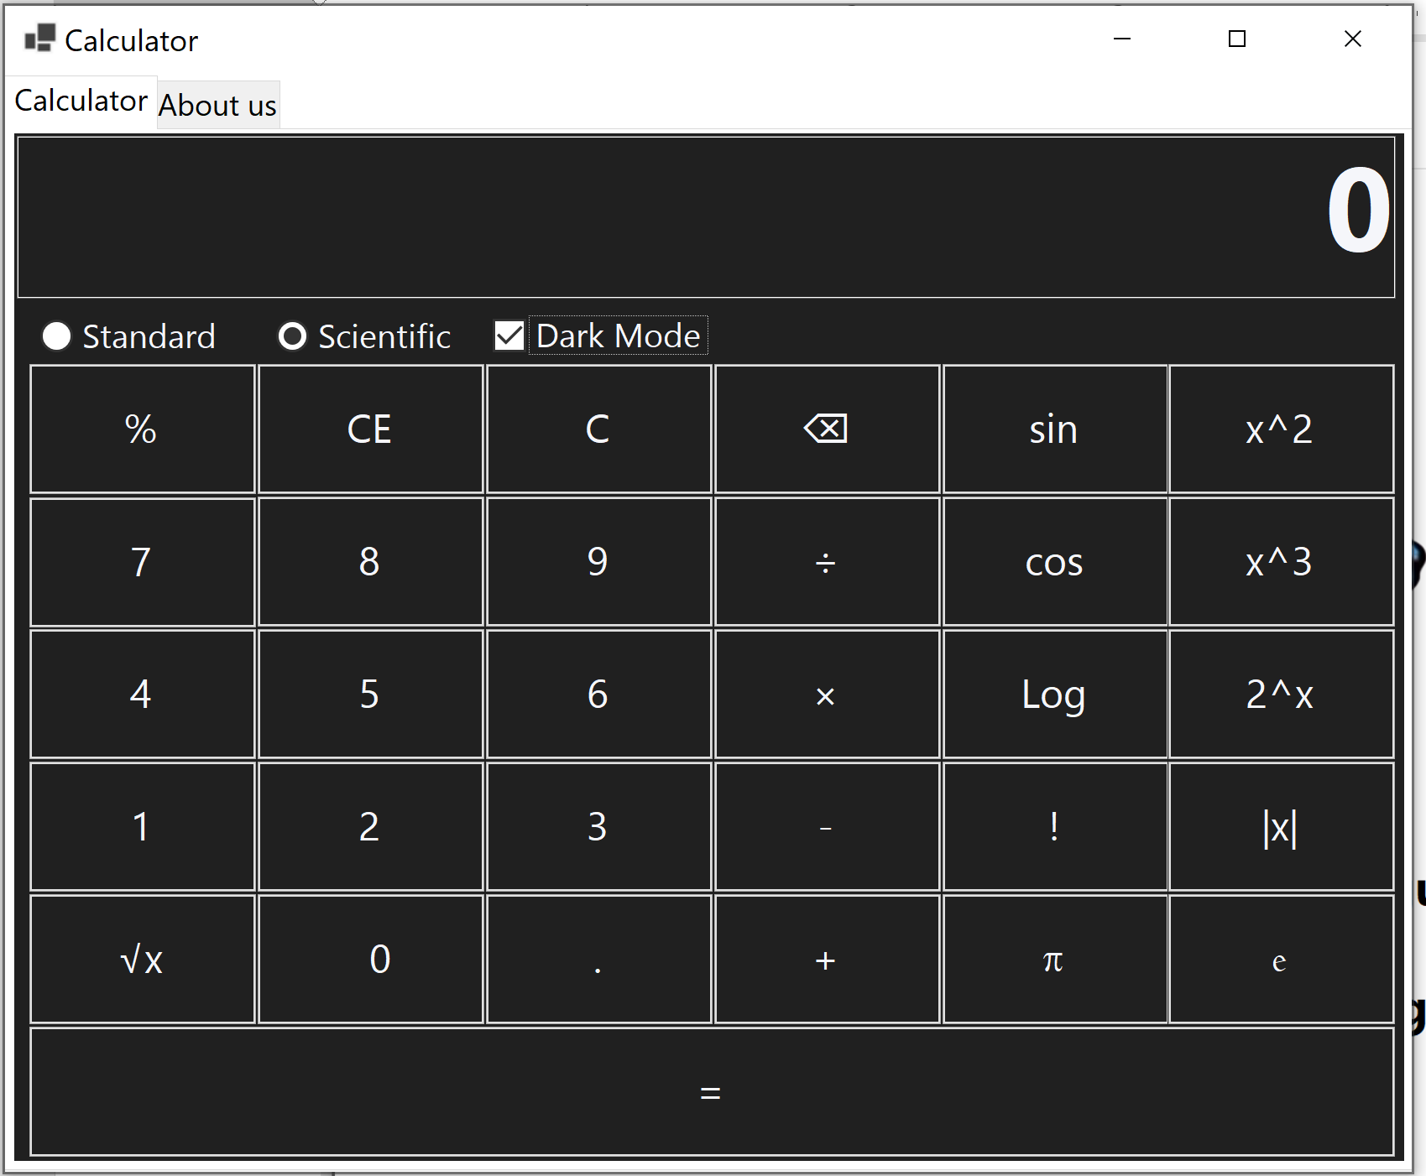

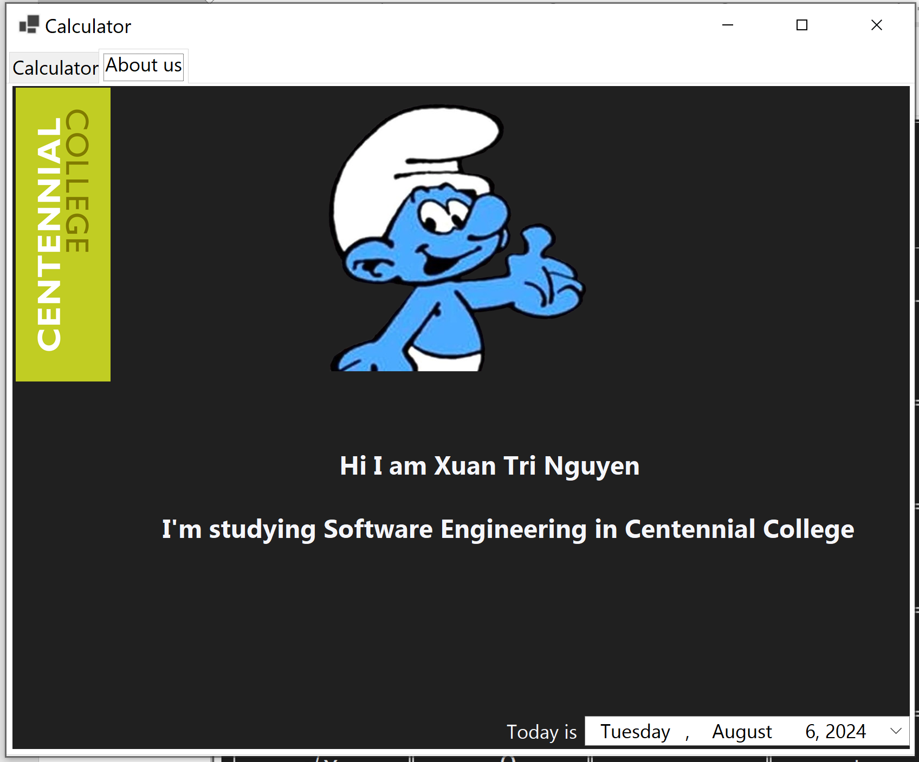

Code text:

using System.Windows.Forms;

using static System.Windows.Forms.VisualStyles.VisualStyleElement;

using static System.Windows.Forms.VisualStyles.VisualStyleElement.ToolBar;

using static System.Windows.Forms.Button;

using System;

namespace Calculator

{

public partial class formCal : Form

{

double firstValue, secondValue;

String op;

public formCal()

{

InitializeComponent();

}

private void chkDark_CheckedChanged(object sender, EventArgs e)

{

if (chkDark.Checked)

{

tabCal.ForeColor = Color.FromArgb(245, 246, 250);

tabCal.BackColor = Color.FromArgb(32, 32, 32);

tabAbout.ForeColor = Color.FromArgb(245, 246, 250);

tabAbout.BackColor = Color.FromArgb(32, 32, 32);

txtDisplay.ForeColor = Color.FromArgb(245, 246, 250);

txtDisplay.BackColor = Color.FromArgb(32, 32, 32);

btnPercent.ForeColor = Color.FromArgb(245, 246, 250);

btnPercent.BackColor = Color.FromArgb(32, 32, 32);

btn1over.ForeColor = Color.FromArgb(245, 246, 250);

btn1over.BackColor = Color.FromArgb(32, 32, 32);

btnClearEntry.ForeColor = Color.FromArgb(245, 246, 250);

btnClearEntry.BackColor = Color.FromArgb(32, 32, 32);

btnClear.ForeColor = Color.FromArgb(245, 246, 250);

btnClear.BackColor = Color.FromArgb(32, 32, 32);

btn0.ForeColor = Color.FromArgb(245, 246, 250);

btn0.BackColor = Color.FromArgb(32, 32, 32);

btn1.ForeColor = Color.FromArgb(245, 246, 250);

btn1.BackColor = Color.FromArgb(32, 32, 32);

btn2.ForeColor = Color.FromArgb(245, 246, 250);

btn2.BackColor = Color.FromArgb(32, 32, 32);

btn3.ForeColor = Color.FromArgb(245, 246, 250);

btn3.BackColor = Color.FromArgb(32, 32, 32);

btn4.ForeColor = Color.FromArgb(245, 246, 250);

btn4.BackColor = Color.FromArgb(32, 32, 32);

btn5.ForeColor = Color.FromArgb(245, 246, 250);

btn5.BackColor = Color.FromArgb(32, 32, 32);

btn6.ForeColor = Color.FromArgb(245, 246, 250);

btn6.BackColor = Color.FromArgb(32, 32, 32);

btn7.ForeColor = Color.FromArgb(245, 246, 250);

btn7.BackColor = Color.FromArgb(32, 32, 32);

btn8.ForeColor = Color.FromArgb(245, 246, 250);

btn8.BackColor = Color.FromArgb(32, 32, 32);

btn9.ForeColor = Color.FromArgb(245, 246, 250);

btn9.BackColor = Color.FromArgb(32, 32, 32);

btnEqual.ForeColor = Color.FromArgb(245, 246, 250);

btnEqual.BackColor = Color.FromArgb(32, 32, 32);

btnPlus.ForeColor = Color.FromArgb(245, 246, 250);

btnPlus.BackColor = Color.FromArgb(32, 32, 32);

btnMinus.ForeColor = Color.FromArgb(245, 246, 250);

btnMinus.BackColor = Color.FromArgb(32, 32, 32);

btnMultiple.ForeColor = Color.FromArgb(245, 246, 250);

btnMultiple.BackColor = Color.FromArgb(32, 32, 32);

btnDivide.ForeColor = Color.FromArgb(245, 246, 250);

btnDivide.BackColor = Color.FromArgb(32, 32, 32);

btnSQRT.BackColor = Color.FromArgb(32, 32, 32);

btnSQRT.ForeColor = Color.FromArgb(245, 246, 250);

btnDot.ForeColor = Color.FromArgb(245, 246, 250);

btnDot.BackColor = Color.FromArgb(32, 32, 32);

btnSin.ForeColor = Color.FromArgb(245, 246, 250);

btnSin.BackColor = Color.FromArgb(32, 32, 32);

btnCos.ForeColor = Color.FromArgb(245, 246, 250);

btnCos.BackColor = Color.FromArgb(32, 32, 32);

btnLog.BackColor = Color.FromArgb(32, 32, 32);

btnLog.ForeColor = Color.FromArgb(245, 246, 250);

btnFact.ForeColor = Color.FromArgb(245, 246, 250);

btnFact.BackColor = Color.FromArgb(32, 32, 32);

btnPi.ForeColor = Color.FromArgb(245, 246, 250);

btnPi.BackColor = Color.FromArgb(32, 32, 32);

btnE.ForeColor = Color.FromArgb(245, 246, 250);

btnE.BackColor = Color.FromArgb(32, 32, 32);

btnAb.BackColor = Color.FromArgb(32, 32, 32);

btnAb.ForeColor = Color.FromArgb(245, 246, 250);

btn2SquareX.ForeColor = Color.FromArgb(245, 246, 250);

btn2SquareX.BackColor = Color.FromArgb(32, 32, 32);

btnCube.ForeColor = Color.FromArgb(245, 246, 250);

btnCube.BackColor = Color.FromArgb(32, 32, 32);

btnSquare.ForeColor = Color.FromArgb(245, 246, 250);

btnSquare.BackColor = Color.FromArgb(32, 32, 32);

}

else

{

tabCal.ForeColor = Color.FromArgb(32, 32, 32);

tabCal.BackColor = Color.FromArgb(245, 246, 250);

tabAbout.ForeColor = Color.FromArgb(32, 32, 32);

tabAbout.BackColor = Color.FromArgb(245, 246, 250);

txtDisplay.ForeColor = Color.FromArgb(32, 32, 32);

txtDisplay.BackColor = Color.FromArgb(245, 246, 250);

btnPercent.ForeColor = Color.FromArgb(32, 32, 32);

btnPercent.BackColor = Color.FromArgb(245, 246, 250);

btn1over.ForeColor = Color.FromArgb(32, 32, 32);

btn1over.BackColor = Color.FromArgb(245, 246, 250);

btnClearEntry.ForeColor = Color.FromArgb(32, 32, 32);

btnClearEntry.BackColor = Color.FromArgb(245, 246, 250);

btnClear.ForeColor = Color.FromArgb(32, 32, 32);

btnClear.BackColor = Color.FromArgb(245, 246, 250);

btn0.ForeColor = Color.FromArgb(32, 32, 32);

btn0.BackColor = Color.FromArgb(245, 246, 250);

btn1.ForeColor = Color.FromArgb(32, 32, 32);

btn1.BackColor = Color.FromArgb(245, 246, 250);

btn2.ForeColor = Color.FromArgb(32, 32, 32);

btn2.BackColor = Color.FromArgb(245, 246, 250);

btn3.ForeColor = Color.FromArgb(32, 32, 32);

btn3.BackColor = Color.FromArgb(245, 246, 250);

btn4.ForeColor = Color.FromArgb(32, 32, 32);

btn4.BackColor = Color.FromArgb(245, 246, 250);

btn5.ForeColor = Color.FromArgb(32, 32, 32);

btn5.BackColor = Color.FromArgb(245, 246, 250);

btn6.ForeColor = Color.FromArgb(32, 32, 32);

btn6.BackColor = Color.FromArgb(245, 246, 250);

btn7.ForeColor = Color.FromArgb(32, 32, 32);

btn7.BackColor = Color.FromArgb(245, 246, 250);

btn8.ForeColor = Color.FromArgb(32, 32, 32);

btn8.BackColor = Color.FromArgb(245, 246, 250);

btn9.ForeColor = Color.FromArgb(32, 32, 32);

btn9.BackColor = Color.FromArgb(245, 246, 250);

btnEqual.ForeColor = Color.FromArgb(32, 32, 32);

btnEqual.BackColor = Color.FromArgb(245, 246, 250);

btnPlus.ForeColor = Color.FromArgb(32, 32, 32);

btnPlus.BackColor = Color.FromArgb(245, 246, 250);

btnMinus.ForeColor = Color.FromArgb(32, 32, 32);

btnMinus.BackColor = Color.FromArgb(245, 246, 250);

btnMultiple.ForeColor = Color.FromArgb(32, 32, 32);

btnMultiple.BackColor = Color.FromArgb(245, 246, 250);

btnDivide.ForeColor = Color.FromArgb(32, 32, 32);

btnDivide.BackColor = Color.FromArgb(245, 246, 250);

btnSQRT.BackColor = Color.FromArgb(245, 246, 250);

btnSQRT.ForeColor = Color.FromArgb(32, 32, 32);

btnDot.ForeColor = Color.FromArgb(32, 32, 32);

btnDot.BackColor = Color.FromArgb(245, 246, 250);

btnSin.ForeColor = Color.FromArgb(32, 32, 32);

btnSin.BackColor = Color.FromArgb(245, 246, 250);

btnCos.ForeColor = Color.FromArgb(32, 32, 32);

btnCos.BackColor = Color.FromArgb(245, 246, 250);

btnLog.BackColor = Color.FromArgb(245, 246, 250);

btnLog.ForeColor = Color.FromArgb(32, 32, 32);

btnFact.ForeColor = Color.FromArgb(32, 32, 32);

btnFact.BackColor = Color.FromArgb(245, 246, 250);

btnPi.ForeColor = Color.FromArgb(32, 32, 32);

btnPi.BackColor = Color.FromArgb(245, 246, 250);

btnE.ForeColor = Color.FromArgb(32, 32, 32);

btnE.BackColor = Color.FromArgb(245, 246, 250);

btnAb.BackColor = Color.FromArgb(245, 246, 250);

btnAb.ForeColor = Color.FromArgb(32, 32, 32);

btn2SquareX.ForeColor = Color.FromArgb(32, 32, 32);

btn2SquareX.BackColor = Color.FromArgb(245, 246, 250);

btnCube.ForeColor = Color.FromArgb(32, 32, 32);

btnCube.BackColor = Color.FromArgb(245, 246, 250);

btnSquare.ForeColor = Color.FromArgb(32, 32, 32);

btnSquare.BackColor = Color.FromArgb(245, 246, 250);

}

}

private void radScientific_CheckedChanged(object sender, EventArgs e)

{

if (radScientific.Checked)

{

this.Size = new Size(1712, 1411);

txtDisplay.Size = new Size(1643, 194);

btnEqual.Size = new Size(1629, 157);

pictProfile.Location = new Point(564, 27);

lblToday.Location = new Point(904, 1171);

Date.Location = new Point(1056, 1164);

lblName.Location = new Point(593, 672);

lblName.Font = new Font("Gadugi", 12, FontStyle.Bold);

lblIntro.Location = new Point(267, 789);

lblIntro.Font = new Font("Gadugi", 12, FontStyle.Bold);

}

}

private void radStandard_CheckedChanged(object sender, EventArgs e)

{

if (radStandard.Checked)

{

this.Size = new Size(1154, 1411);

txtDisplay.Size = new Size(1102, 194);

btnEqual.Size = new Size(1088, 157);

pictProfile.Location = new Point(301, 6);

lblToday.Location = new Point(349, 1163);

Date.Location = new Point(504, 1155);

lblName.Location = new Point(301, 675);

lblName.Font = new Font("Gadugi", 10, FontStyle.Bold);

lblIntro.Location = new Point(12, 777);

lblIntro.Font = new Font("Gadugi", 10, FontStyle.Bold);

}

}

private void button14_Click(object sender, EventArgs e)

{

}

private void btnPercent_Click(object sender, EventArgs e)

{

double num;

num = Convert.ToDouble(txtDisplay.Text) / 100;

txtDisplay.Text = Convert.ToString(num);

}

private void tabCal_Click(object sender, EventArgs e)

{

}

private void button3_Click(object sender, EventArgs e)

{

}

private void txtDisplay_TextChanged(object sender, EventArgs e)

{

}

private void btnCos_Click(object sender, EventArgs e)

{

double cos = Convert.ToDouble(txtDisplay.Text);

cos = Math.Cos(cos);

txtDisplay.Text = Convert.ToString(cos);

}

private void btnSquareY_Click(object sender, EventArgs e)

{

double x = Convert.ToDouble(txtDisplay.Text);

double y = Convert.ToDouble(txtDisplay.Text);

double result = Math.Pow(x, y);

txtDisplay.Text = Convert.ToString(result);

}

private void pictureBox1_Click(object sender, EventArgs e)

{

}

private void dateTimePicker1_ValueChanged(object sender, EventArgs e)

{

}

private void pictureBox1_Click_1(object sender, EventArgs e)

{

}

private void tabAbout_Click(object sender, EventArgs e)

{

}

private void lblToday_Click(object sender, EventArgs e)

{

}

private void Number(object sender, EventArgs e)

{

System.Windows.Forms.Button number = (System.Windows.Forms.Button)sender;

if (txtDisplay.Text == "0")

txtDisplay.Text = "";

{

if (number.Text == ".")

{

if (!txtDisplay.Text.Contains("."))

txtDisplay.Text = txtDisplay.Text + number.Text;

}

else

{

txtDisplay.Text = txtDisplay.Text + number.Text;

}

}

}

private void btnDot_Click(object sender, EventArgs e)

{

}

private void Operator(object sender, EventArgs e)

{

System.Windows.Forms.Button number = (System.Windows.Forms.Button)sender;

firstValue = Convert.ToDouble(txtDisplay.Text);

op = number.Text;

txtDisplay.Text = "";

}

private void btnEqual_Click(object sender, EventArgs e)

{

secondValue = Convert.ToDouble(txtDisplay.Text);

switch (op)

{

case "+":

txtDisplay.Text = (firstValue + secondValue).ToString();

break;

case "-":

txtDisplay.Text = (firstValue - secondValue).ToString();

break;

case "×":

txtDisplay.Text = (firstValue * secondValue).ToString();

break;

case "÷":

txtDisplay.Text = (firstValue / secondValue).ToString();

break;

default:

break;

}

}

private void btnClear_Click(object sender, EventArgs e)

{

txtDisplay.Text = "0";

}

private void btnClearEntry_Click(object sender, EventArgs e)

{

txtDisplay.Text = "0";

String first, second;

first = Convert.ToString(firstValue);

second = Convert.ToString(secondValue);

first = "";

second = "";

}

private void btn1over_Click(object sender, EventArgs e)

{

if (txtDisplay.Text.Length > 0)

{

txtDisplay.Text = txtDisplay.Text.Remove(txtDisplay.Text.Length - 1, 1);

}

if (txtDisplay.Text == "")

{

txtDisplay.Text = "0";

}

}

private void btnPi_Click(object sender, EventArgs e)

{

txtDisplay.Text = $"{(Math.PI):F4}";

}

private void btnLog_Click(object sender, EventArgs e)

{

double log = Convert.ToDouble(txtDisplay.Text);

log = Math.Log10(log);

txtDisplay.Text = Convert.ToString(log);

}

private void btnSQRT_Click(object sender, EventArgs e)

{

double sqrt = Convert.ToDouble(txtDisplay.Text);

sqrt = Math.Sqrt(sqrt);

txtDisplay.Text = Convert.ToString(sqrt);

}

private void btnSquare_Click(object sender, EventArgs e)

{

double num;

num = Convert.ToDouble(txtDisplay.Text) * Convert.ToDouble(txtDisplay.Text);

txtDisplay.Text = Convert.ToString(num);

}

private void btnSin_Click(object sender, EventArgs e)

{

double sin = Convert.ToDouble(txtDisplay.Text);

sin = Math.Sin(sin);

txtDisplay.Text = Convert.ToString(sin);

}

private void btnE_Click(object sender, EventArgs e)

{

txtDisplay.Text = $"{(Math.E):F4}";

}

private void btn2SquareX_Click(object sender, EventArgs e)

{

double num;

num = Math.Pow(2, Convert.ToDouble(txtDisplay.Text));

txtDisplay.Text = Convert.ToString(num);

}

private void btnAb_Click(object sender, EventArgs e)

{

if (Convert.ToDouble(txtDisplay.Text) < 0)

{

txtDisplay.Text = Convert.ToString(-Convert.ToDouble(txtDisplay.Text));

}

}

private void btnFact_Click(object sender, EventArgs e)

{

}

private void btnFact_Click_1(object sender, EventArgs e)

{

if (Convert.ToDouble(txtDisplay.Text) < 0)

{

MessageBox.Show("Factorial cannot be negative");

}

int num = 1;

for (int i = 2; i <= Convert.ToDouble(txtDisplay.Text); i++)

{

num *= i;

}

txtDisplay.Text = Convert.ToString(num);

}

private void btnCube_Click(object sender, EventArgs e)

{

double num;

num = Convert.ToDouble(txtDisplay.Text) * Convert.ToDouble(txtDisplay.Text) * Convert.ToDouble(txtDisplay.Text);

txtDisplay.Text = Convert.ToString(num);

}

private void formCal_Load(object sender, EventArgs e)

{

}

}

}